## Targets Super Admin

Requirements:

No requirement yet �

|  |  |  |
| --- | --- | --- |
| Title � | Enter Requirement  � | +Add Requirement  (Button) � |

## Targets Unit Heads

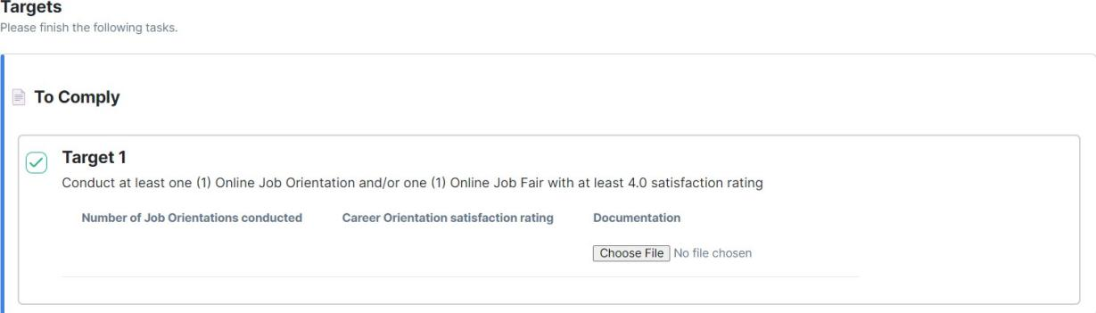

|  |
| --- |
| Target 1 (from Title) � |
| Conduct at least one (from Enter Requirement) � |

|  |  |  |
| --- | --- | --- |
| Number of Job  Dropdown  **Type of Input:**  * Percentage [%]  * Ǫuantity [ ] | Career  Dropdown  **Type of Input:**  * Percentage [%]  * Ǫuantity [ ] | Documentation  � |

**#Done**

**To remove:**

Google Auth Web Console Project for Unit Heads

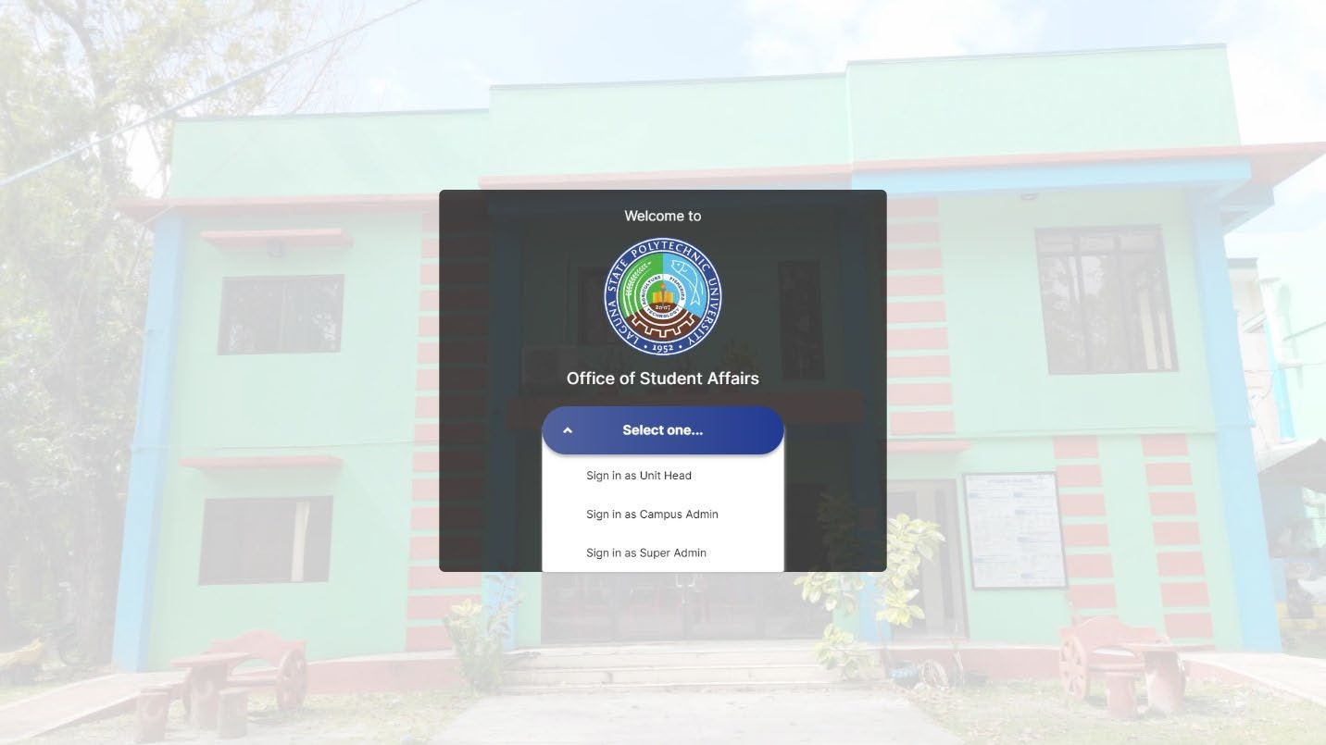

**# Done**

Sign-in as Unit Head only:

Login

Don’t have an account yet? [Hyperlink for Registration Page] Registration Page:

* First Name:
* Last Name:
* Email:
* Password:
* Office:
* Campus:

## Note:

In Super Admin, adding Unit heads will not be a google-based client anymore. **#Noted**

## To rename:

From “For Reviewal” to “For Review” in <https://lspuosas.online/admin/user-objectives> (Targets > Reviewal) sa may **Action** column **#Done**

## To fix:

* In Calendar, April 30 as of now, you can’t put an entry sa mga previous date. **#done**
* **Dynamic load** dapat daw according to panel namin during final defense, regarding sa Targets Entry and **Targets Dashboard** kapag nag-click ng checkbox as **Done** at kapag nag-click ng **Submit** button kasi nire-reload pa daw. **#done**
* **Office / Unit Heads** ay ‘di pwedeng mag-input ng advance date sa “Accomplished

Date” entry field, sa **“Submission Bin”** ‘yun ng office.

* If April 30 ngayon, advance date onwards, e.g. May 01, dapat may popup box that indicates a catch error na you can’t add an entry submission more than this day. **#Done**

* Can't preview the image uploaded in **Announcement** before i-publish ‘yung post, + can upload multiple images rin. - Ipapakita ang image bago mag-upload **#done**
* Comment Input field (submit) in Submission Bin * not working
* **Cancel** hyperlink when creating objective**,** dapat kay

<https://lspuosas.online/admin/objectives/32/edit> mapupunta. **#Done**

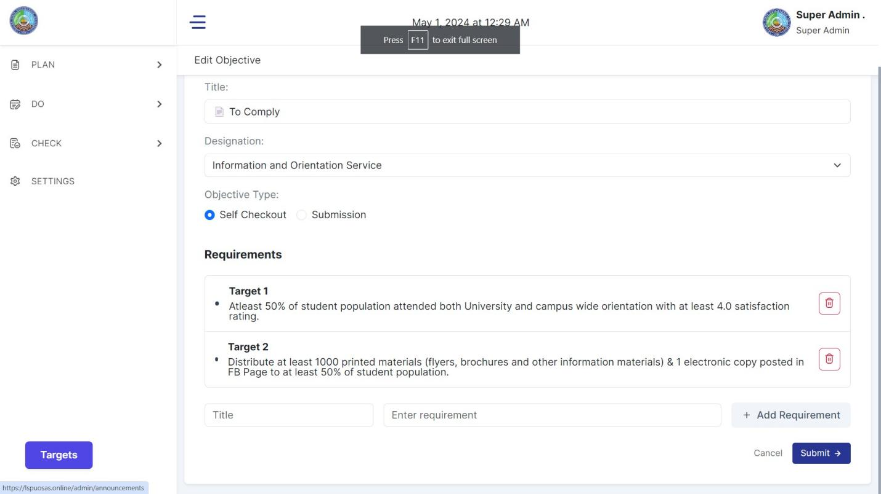

•

#

* In Targets, display text aligned as “**Justify**” **#done**
* Dikit-dikit yung text sa **“Actual Accomplishment” #done**

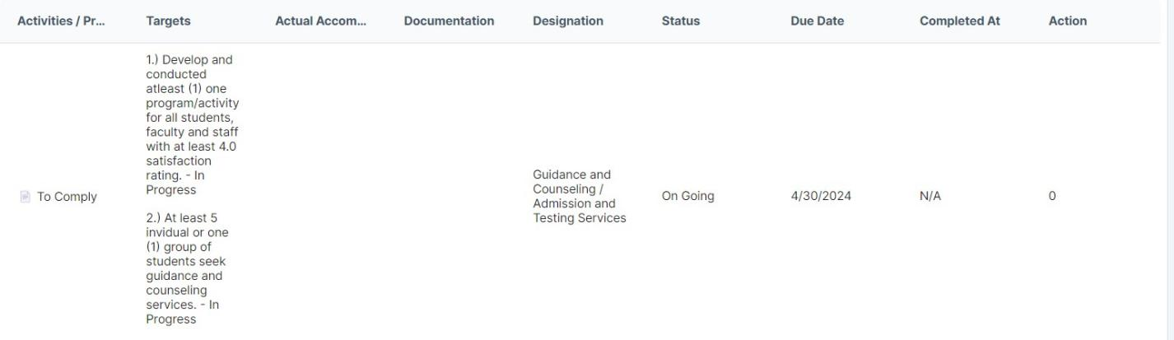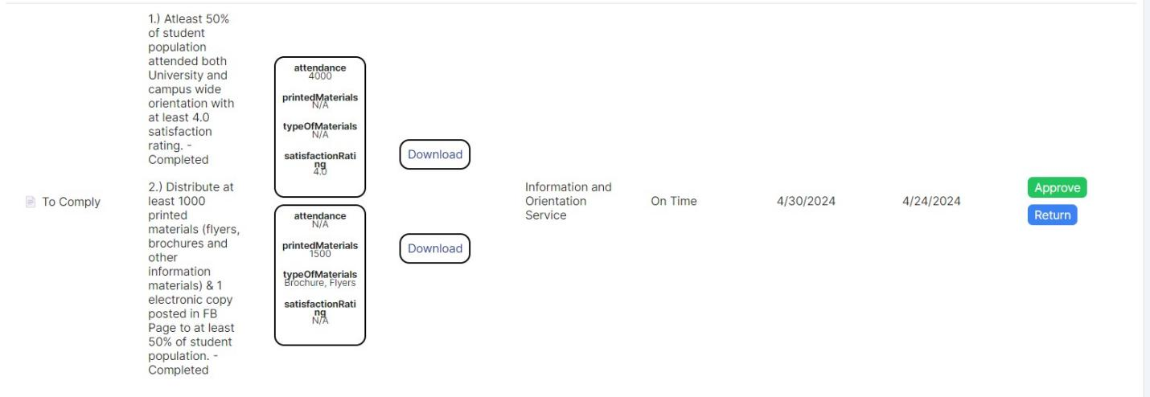

* Action na 0 kapag nagsusubmit pa lang si Unit Heads, displayed as “Waiting.” **#done**

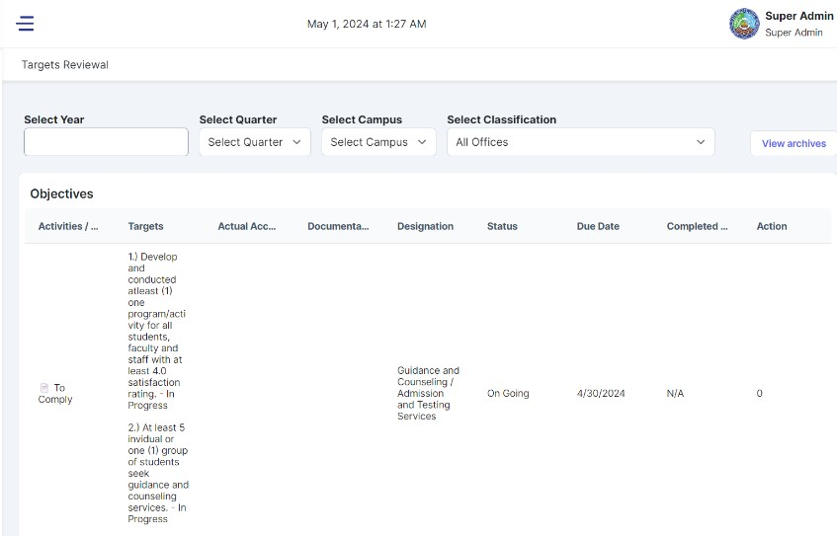

* Maayos din daw sana ‘yung Targets na mga text kasi humahaba, fixed view, if need i- view, magpop-up na lang yung full info ng “Targets”. **#For meeting**
* No document uploaded, it should be required to upload document when office

submit their targets, at nasusubmit ang target ket walang document na inupload.**#done**

## To Modify:

* Targets Floating button, dapat may tatlong mag-ho-hover na logo:

**Icon 1:** Create Target, **Icon 2:** Reviewal, **Icon 3:** Archived.

* I-mo-move si Create Target or <https://lspuosas.online/admin/objectives>, sa Navigation bar na **“DO” #Done**
* All words from the system na “Designation”, will rename as “Office” **#Done**
* **Office Targets Reviewal** “Download” button should be Blue button. **#Done**
* **Office Targets Reviewal** - Table row not taking/occupy full width (There should be horizontal scroll bar), at ‘di nakikita yung mga item per row sa table. **#Done**
* Ymga lines ni table dapat daw visible into black, see several images here: **#Done**

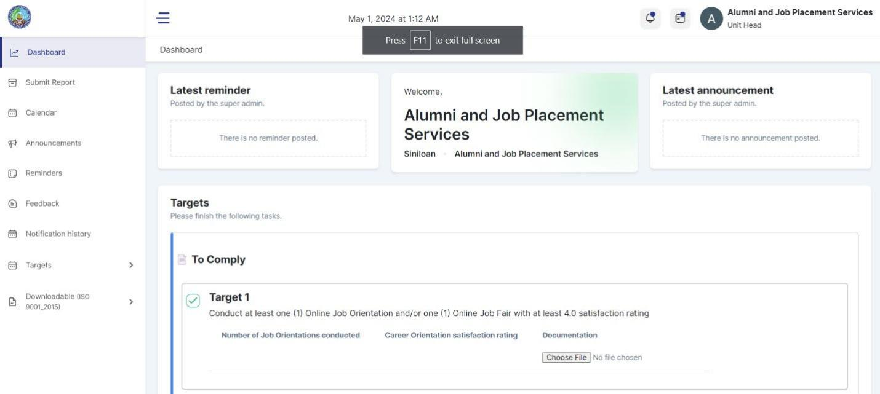

* Lahat ng may column sa system is dapat visible yung mga lines as black 100%. **#done**
* v�zLatest Reminder, � Latest Reminder, need i-insert yung emoji na dalawa. **#done**
* Welcome Card should not be sizable but need i-adjust yung left and right. **#done**
* To adjust the card for Latest Reminder in Left and Latest Announcement as Right,

fixed position but increasing yung card pababa depende sa content. **#done**

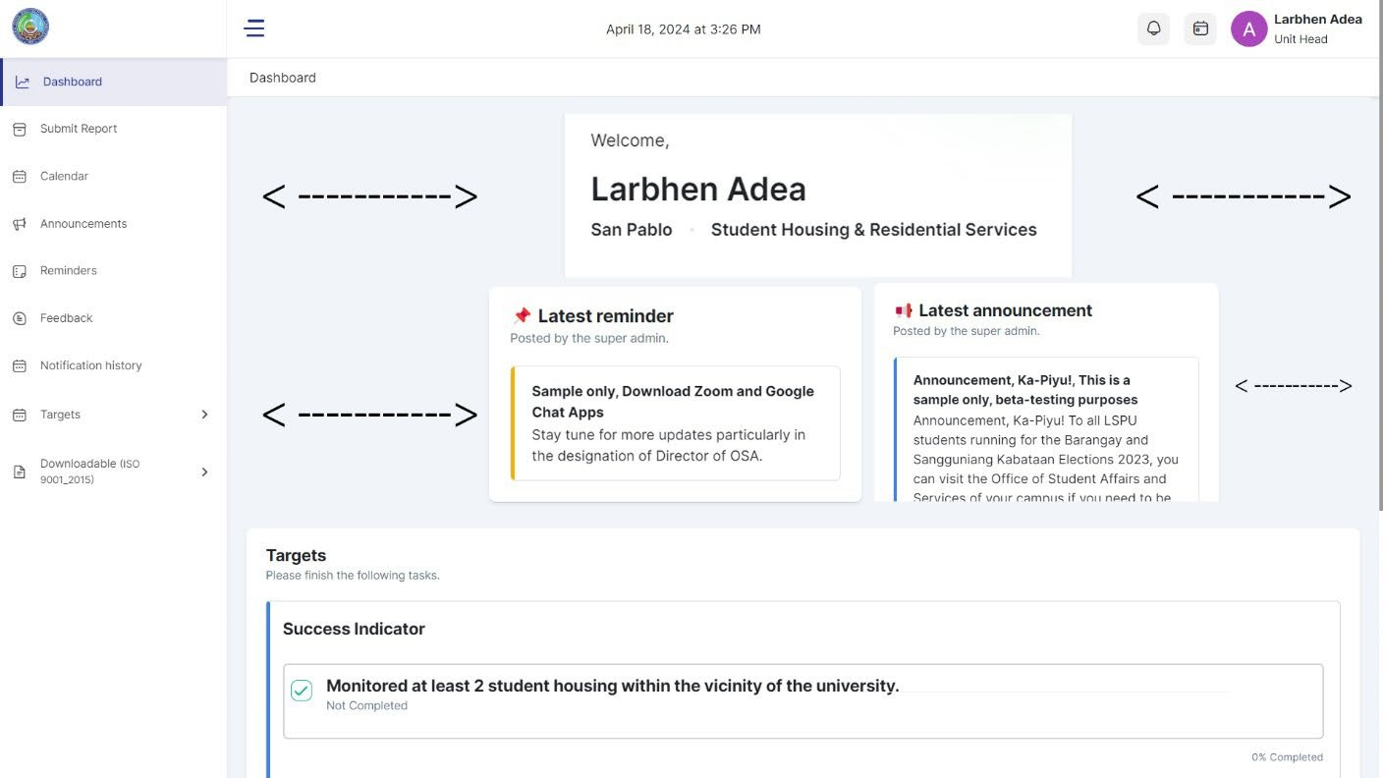

## To add:

* Submission Bin Floating Target button with hover four icon (same as target): **Icon 1:** Create Submission Bin [https://lspuosas.online/admin/document-](https://lspuosas.online/admin/document-tracking/submission-bins) [tracking/submission-bins](https://lspuosas.online/admin/document-tracking/submission-bins)

**Icon 2:** For Review [https://lspuosas.online/admin/document-tracking/reports/for-](https://lspuosas.online/admin/document-tracking/reports/for-review) [review](https://lspuosas.online/admin/document-tracking/reports/for-review).

**Icon 3:** To generate reports https://lspuosas.online/admin/generated-reports- annually

**Icon 4:** Archived Reports: [https://lspuosas.online/admin/document-](https://lspuosas.online/admin/document-tracking/reports/archive) [tracking/reports/archive](https://lspuosas.online/admin/document-tracking/reports/archive)

* Notifications in Targets same as Submission bin
* Confirmation popup of creating “Targets”- “Submission Bin” before clicking Submit.
* Implement **row per page** in Submission Bin (For Review) + Targets (For Review), dapat kayang makapag-input kung ilang rows per page yung gusto palabasin, and not limited in 100 lang, pwede dapat kung ilan kasi baka abutin ng thousands yung entry na mga reports. **Row per page: 1000**



* Implement triangle sort in all tables esp. kay Submission Bin (For Review, To Generate Reports, Archived Reports) + Targets (For Review and Archived) sa row item, apply to all.

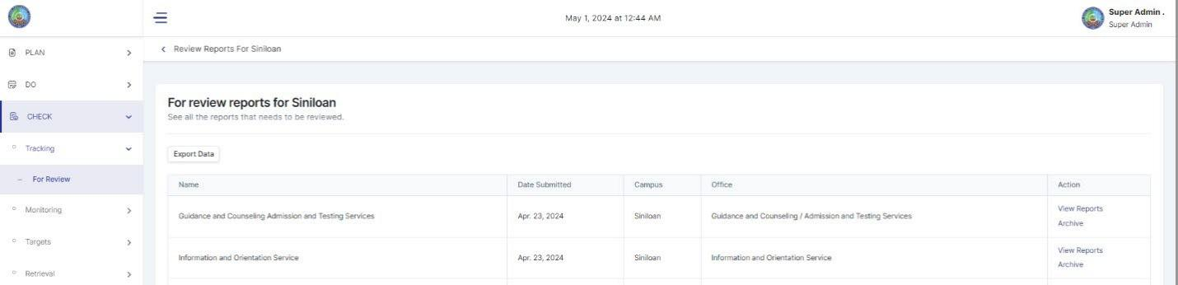

# SUPER ADMIN

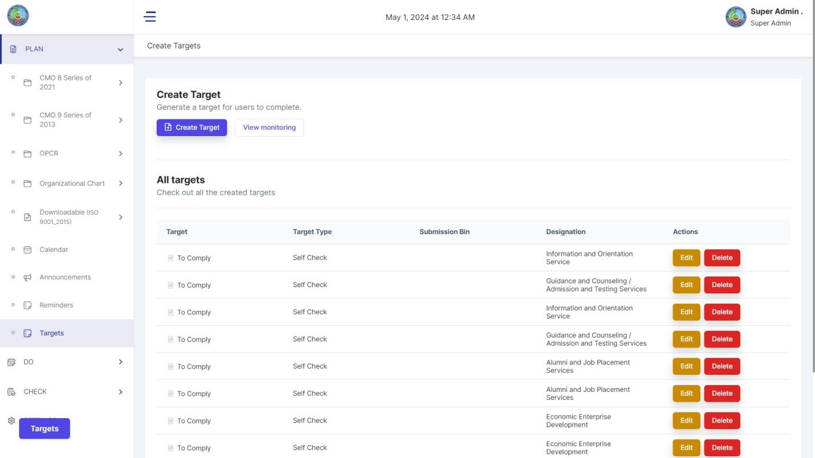

PLAN > TARGETS will now be under DO. Implementation as Tabbed Interface

DO:

# TARGETS

* Unit Heads Profiles
* Add Campus Admin
* Manage Unit Heads
* **Targets** (Clicked)
* Submission Bin

|  |  |
| --- | --- |
| **Targets** | Submission Bin |

Eto interface ni Targets, dito magloloading lahat ng related kay Targets:

Loading pages:

* <https://lspuosas.online/admin/objectives>
* <https://lspuosas.online/admin/objectives/create>
* <https://lspuosas.online/admin/user-objectives>
* https://lspuosas.online/admin/user-objectives/archives

# SUBMISSION BIN

* Unit Heads Profiles
* Add Campus Admin
* Manage Unit Heads
* Targets
* **Submission Bin** (clicked)

|  |  |
| --- | --- |
| Targets | **Submission Bin** |

While kay Submission bin, dito rin magloloading lahat ng related kay Submission Bin:

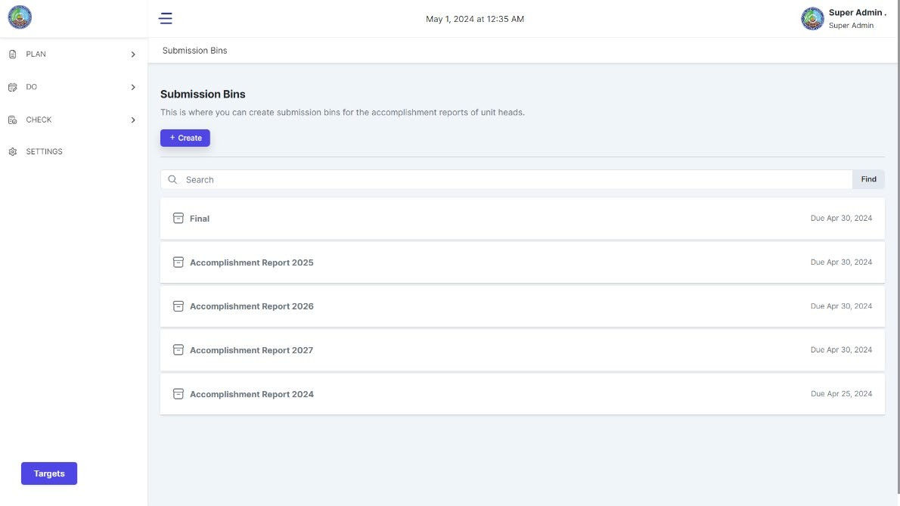

Loading pages:

* <https://lspuosas.online/admin/document-tracking/submission-bins>
* <https://lspuosas.online/admin/document-tracking/submission-bins/create>
* <https://lspuosas.online/admin/document-tracking/reports/for-review>
* <https://lspuosas.online/admin/document-tracking/reports/for-review/Siniloan>
* <https://lspuosas.online/admin/document-tracking/reports/for-review/Sta.%20Cruz>
* [https://lspuosas.online/admin/document-tracking/reports/for-](https://lspuosas.online/admin/document-tracking/reports/for-review/Los%20Ba%C3%B1os) [review/Los%20Ba%C3%B1os](https://lspuosas.online/admin/document-tracking/reports/for-review/Los%20Ba%C3%B1os)
* <https://lspuosas.online/admin/document-tracking/reports/for-review/San%20Pablo>
* <https://lspuosas.online/admin/generated-reports-annually>
* <https://lspuosas.online/admin/document-tracking/reports/archive>

**TABBED GROUP (VISUALIZATION)**

